A

PROJECT REPORT ON

Easy Pay App

**An Online Recharge System application**

SUBMITTED IN PARTIAL FULFILLMENT OF

DIPLOMA IN ADVANCED COMPUTING (PG-DAC)

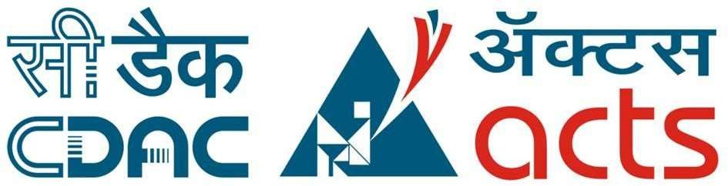

UNDER THE GUIDANCE OF

**Ms.Sunandha Ma’am.**

: PRESENTED BY :

|  |  |  |
| --- | --- | --- |
| 230360820049 |  | Shreyas Vishwas Kamble. |
| 230360820052 |  | Shubham Rangnath Waghchoure. |
|  |  |  |
|  |  |  |
|  |  |  |
|  |  |  |

**CENTER FOR DEVELOPMENT OF ADVANCED COMPUTINGC-DAC,CHENNAI**

# ACKNOWLEDGEMENT

The project “Easy Pay App” was a great learning experience for us and we are submitting this work to Advanced Computing Training School (C-DAC, CHENNAI).

We are very glad to mention the name of Ms. Sunandha Ma’am for her valuable guidance to work on this project.

We would like to express our sincere gratitude towards all our faculty of Cdac Chennai who was always there for us. Their guidance and support throughout the course helped us to overcome various obstacles and intricacies during the course of our project work. Without their tremendous support, guidance, and efforts, this project would not have been possible.

**:FROM:**

|  |  |
| --- | --- |
| 230360820049 | Shreyas Vishwas Kamble |
| 230360820052 | Shubham Rangnath Waghchoure |
|  |  |
|  |  |
|  |  |
|  |  |

## TABLE OF CONTENTS

1. INTRODUCTION

2. PRODUCT OVERVIEW AND SUMMARY

* 1. Purpose
  2. Scope
  3. Overview
  4. Feasibility Study

3. REQUIREMENTS FULFILLED

* 1. Functional Requirements
  2. Non-Functional Requirements

4. PROJECT DESIGN

* 1. Data Model
  2. Use Case Diagram
  3. Activity Diagram

5. PROJECT SCREENSHOTS

* 1. Customer
  2. Admin

1. TESTING
2. CONCLUSION
3. FUTURE SCOPE
4. REFERENCES

ABSTRACT

The rapid growth of online services has led to an increasing demand for convenient and secure platforms for digital transactions. The "EasyPay" app system aims to provide users with a seamless experience for online recharge services using the Spring Framework. This project outlines the development of an efficient and user-friendly application that enables users to recharge various services such as mobile prepaid plans,subscriptions, and utility bill payments.

The application leverages the Spring Framework to achieve robustness, flexibility, and scalability. The Spring Framework provides a comprehensive ecosystem for building Java-based enterprise applications, offering features such as dependency injection, aspect-oriented programming, and various modules for web development. By utilizing the Spring Framework, the EasyPay app system can ensure modularity and maintainability throughout the development process.

This project deals with developing an e-commerce website for online mobile recharge. It provides list of offers and bills to the users. It also provides offerslist by which user can make a choice for recharge plans. The user can also view their recharge history in user section.

The main technologies were used in this project: Java Spring and Hibernate. Java was used for backend. Html,Css,Jsp is used for frontend and provides a fluid single page experience. MySQL has been used as database to store list of users, recharge and their offers and bills.

This project has been designed and implemented in multilevel architecture so as to have minimum coupling and maximum cohesion.

# 1 .INTRODUCTION

In a digitally-driven world, staying connected is non-negotiable, making online recharges a part of our routine. Welcome to EasyPay - the epitome of convenient online recharge solutions, fortified by the dynamic capabilities of the Spring Framework.

In this fast-paced era, EasyPay emerges as a user-friendly online recharge application, meticulously crafted to cater to mobile top-ups, service renewals, and beyond. The core strength of EasyPay lies in its seamless integration with the Spring Framework, forming a synergy that enhances the online recharge experience.

As we dive into the details of EasyPay, the Spring Framework stands as the pillar of its strength. With its modular architecture, comprehensive tools, and Java-based foundation, Spring empowers EasyPay to deliver a secure, scalable, and efficient platform for managing digital recharges.

Stay tuned as we delve deeper into the world of EasyPay, exploring how its user-centric design, robust security measures, and adaptability all find their roots in the Spring Framework. Witness the evolution of online recharge systems, where cutting-edge technology meets user convenience, all under the banner of EasyPay.

The primary objective of the Mobile Recharge App is to provide users with a convenient, user-friendly platform for recharging their mobile phone balances, purchasing data plans, and availing various telecom services. This app aims to streamline the process of mobile recharge, making it efficient, secure, and accessible to a wide range of users.

# PRODUCT OVERVIEW AND SUMMARY

* 1. **PURPOSE**

The primary purpose of developing a mobile recharge app is to provide users with a comprehensive and user-friendly platform for managing their mobile plans and recharges seamlessly. The app aims to address the inconvenience associated with traditional methods of mobile recharge, such as physical recharge cards or visiting retail outlets. By offering a variety of mobile prepaid plans from different telecom operators, the app caters to diverse user preferences and usage patterns. This variety ensures that users can easily find and customize plans that suit their specific needs, whether it's data plans, talk-time recharges, SMS packs, or special offers.

One of the app's key objectives is to enhance user convenience through instant and secure recharge transactions. Users can recharge their mobile plans instantly, ensuring uninterrupted connectivity and catering to emergency situations where immediate recharge is required. The app's user-friendly interface plays a crucial role in achieving this purpose, as it simplifies the process of plan selection, payment, and transaction history tracking. The app also emphasizes security, implementing robust measures such as encryption and secure communication protocols to protect users' personal and financial information during transactions.

Moreover, the app contributes to the ongoing digital transition by providing a platform for cashless transactions and reducing the reliance on physical recharges. It promotes a digital economy by offering multiple payment options, including credit/debit cards, digital wallets, net banking, and UPI. Beyond transactions, the app serves as an engagement tool, sending users notifications and reminders about low balances, plan expirations, and special offers, thus keeping them informed and engaged with their mobile plans.

A significant aspect of the app's purpose is to establish a brand presence in the digital payment and recharge sector. Through exclusive offers, discounts, and cashback deals on recharge transactions, the app aims to incentivize repeat usage and foster customer loyalty. Furthermore, the app seeks to gather valuable user insights through data analysis, allowing for the identification of trends, preferences, and behaviors. This information can be used to refine services, offer more tailored plans, and continually enhance the user experience.

Overall, the project envisions the mobile recharge app as a holistic solution that not only simplifies the recharge process but also contributes to the shift towards a digital economy. Through convenience, variety, security, engagement, and insights, the app aims to establish itself as a reliable and user-centric platform for managing mobile plans and recharges.

# SCOPE

The scope of this project encompasses the comprehensive development and implementation of a mobile recharge app that offers a wide array of features to enhance user convenience and digital engagement. The app will cover the entire user journey, beginning with user registration and authentication, allowing users to create secure accounts and log in seamlessly. It will provide a well-organized catalog of diverse mobile prepaid plans from various telecom operators, empowering users to select and customize plans based on their specific requirements, whether it's data usage, talk-time, or special offers.

Furthermore, the project will involve creating an intuitive and user-friendly interface, accommodating users of various technical backgrounds and age groups. The scope includes incorporating customer support features like live chat or a helpline to provide prompt assistance to users in case of any issues.

While the project's primary focus is on the development of the mobile recharge app and its immediate functionalities, it's important to note that the scope does not extend to broader considerations like marketing strategies, deployment, or long-term maintenance. Ultimately, the scope encompasses the full cycle of user interaction, transaction processing, security, engagement, and data insights within the context of a mobile recharge application.

# OVERVIEW

###### A.TECHNOLOGIES USED

1. **FRONT END**
   * HTML
   * CSS
   * Jsp
   * Bootstrap
2. **BACK END**
   * Spring
   * Hibernate
3. **DATABASE MANAGEMENT SYSTEM**
   * MySQL

###### B. FEATURES PROVIDED

1. FOR ADMIN:-

**Browse** - Admin can browse the homepage to explore the entire welcome page.

* + **Login & Logout** – Similar to user, admins can login & logout to access their account.
  + **Add offers** –Only admin is responsible for adding the details of offers for users.
  + **Update offers** –Only admin is responsible for updating the details of offers for users.
  + **Delete offer** –The admins can delete a offer if they need to for any purpose.
  + **View Offers** – Admins can see the offers lists , which is set by him.

1. FOR USERS

**Browse** – Customers can browse the homepage to explore the entire welcome page.

* + **Register**– New user can register on the site.
  + **Login & Logout** - Existing users can then login to access their account information and logout when the account is not in use.
  + **Forgot Password**: User can change the password if he forgot the password
  + **Welcome page for user** – When logged in, users can view various like recharge,offers and see your bills.
  + **Offers** – In this option user can choose the recharge plan which is set by admin.
  + **Recharge** – In this option user can recharge on his mobile by providing details to various fields like,mobile numbers ,plan,recharge amount.
  + **See Your Bills** – Every user can view their recharge history in order to get an idea about their past spending.

# FEASIBILITY STUDY

Feasibility is the determination of whether a project is worth undertaking or not. Before actually recommending the new system, it is important to investigate if it is feasible to develop it.

Before developing and implementing a system, we have to make sure that the system

is feasible in the following ways:

### A.TECHNICAL FEASIBILITY:

In this type of feasibility study, the system analyst has to check whether it is possible or not to develop the requested system with the available manpower, software, hardware, etc.

The technical feasibility of developing a mobile recharge app using the Spring Framework and Hibernate for a software project is robust. The Spring Framework's modular architecture and rich feature set make it well-suited for building complex applications. Its dependency injection mechanism, coupled with Aspect-Oriented Programming (AOP), simplifies development and maintenance by enhancing code modularity and allowing the incorporation of cross-cutting concerns like security and transactions. Spring MVC facilitates the creation of the app's user interface and interaction.

When coupled with Hibernate, the technical feasibility increases significantly. Hibernate's Object-Relational Mapping (ORM) capabilities streamline database operations, allowing developers to interact with relational databases using Java objects. The mapping of Java classes to database tables simplifies data retrieval and storage, reducing the need for manual SQL queries. Hibernate's database independence ensures compatibility with various database systems, enhancing flexibility. Its caching and lazy loading mechanisms optimize performance by minimizing database queries and loading data only when required.

Overall, the combination of Spring Framework and Hibernate offers a powerful toolkit for building a secure, scalable, and efficient mobile recharge app. Despite potential learning curves, the active communities and extensive documentation for both frameworks contribute to their technical feasibility. The modularity, maintainability, and community support make these technologies suitable for creating a feature-rich app capable of handling the intricacies of online recharges and financial transactions.

### B. OPERATIONAL FEASIBILITY

In this type of feasibility study, the operation of the system is considered. An analysis is performed on whether it is feasible for the user department to use the application. Thus, the proposed system is said to be operationally feasible only if clients are able to understand the system clearly and correctly, and can use it with ease.

In the design of this project, we always kept user experience in mind. We made an effort to have a good user interface with consistent theme and alluring design to keep the users interested and engaged. In our project, the use of universally known icons and instructions that are easy to understand makes sure that the user will not need any special technical know-how to use the application. We made sure that the information available throughout the application is arranged in a logically coherent and consistent manner, guaranteeing that the users will have a smooth and effortless experience and even enjoy using the application.

### C. ECONOMICAL FEASIBILITY:

In this type of feasibility study, the benefits of the system to the organization are considered by taking into consideration the cost-benefit analysis. All the software and technologies used in our project free, open-source, and widely available, with each of the technologies having an extensive community support. This makes “Easy Pay App” an economically feasible solution to the organizations that wish to implement it.

# REQUIREMENTS FULFILLED

#### FUNCTIONAL REQUIREMENTS

Following are the functional requirements fulfilled by our project:

* Welcome Page For Admin And User
* Register page for new users.
* Login page for already registered users.
* Forgot Password Option For User
* After Login As User ,User Home Page Will PopUp
* Recharge Page
* Payment Gateway
* Bills Page And Offer Page
* Login Page For Admin
* Add Offer Page For Admin
* View Offer Page For Admin
* LogOut

#### NON-FUNCTIONAL REQUIREMENTS

Following are the non-functional requirements fulfilled by our project:

* **Usability:**

Usability of application will be easy so that new customer can use it without any difficulty.

* **Maintainability:**

Application would build up in such a way that classifications of errors and maintenance become easy.

* **Security:**
  + - No one can use this application without a registered username and password.
    - Safe and secure.
* **Reliability:**

The System will support 7 X 24 operations.

* **Performance:**
  + - Authorization will complete within one minute 90% of the time.
    - Average authorization confirmation time will not exceed 30 seconds.
* **Access:**

Software will accessible over the internet.

1. **PROJECT DESIGN**

##### **DATA MODEL**

The following tables depict the database design:

* + 1. **Tables Related to User Details**
       1. Users Model

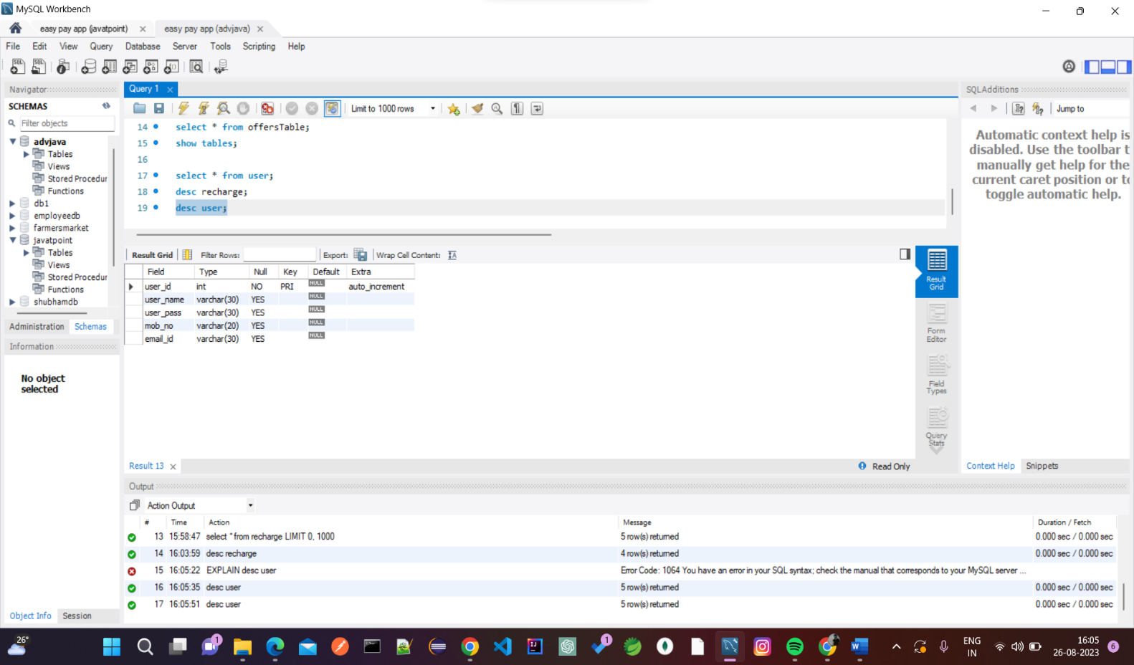

* + - 1. Users Table

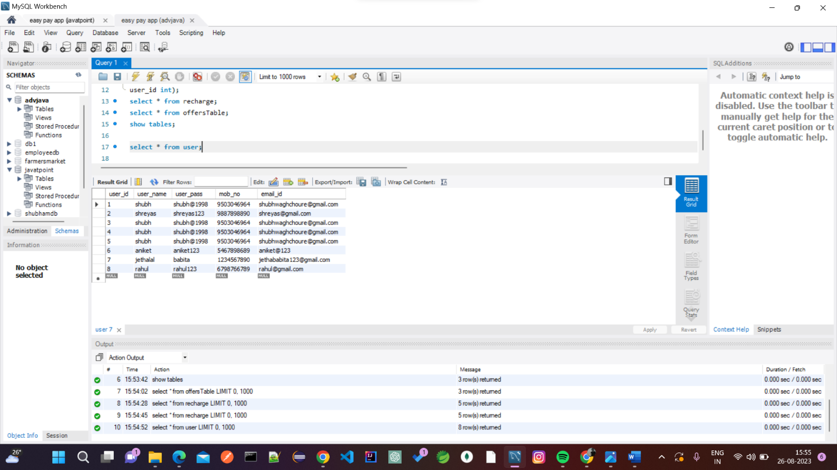

* + 1. **Tables Related to Recharge**
       1. Recharge Model

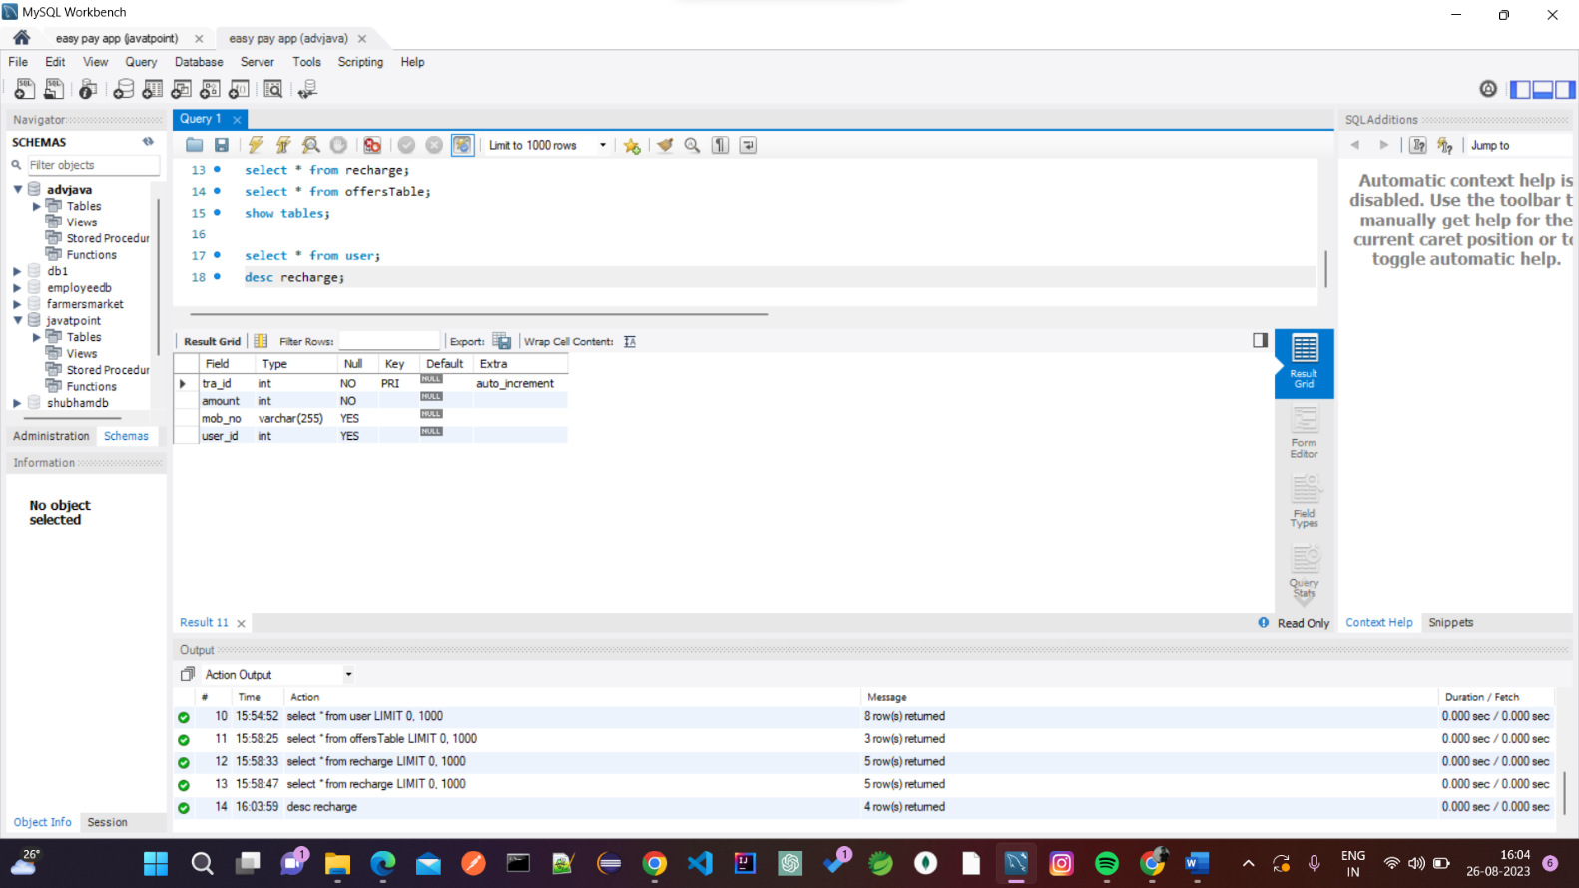

* + - 1. Recharge Table

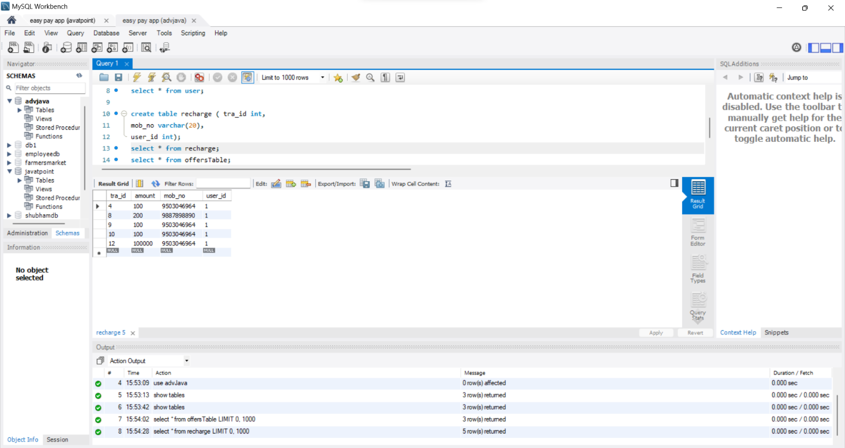

* + 1. **Tables Related to OFFERS**

1. Offers Model

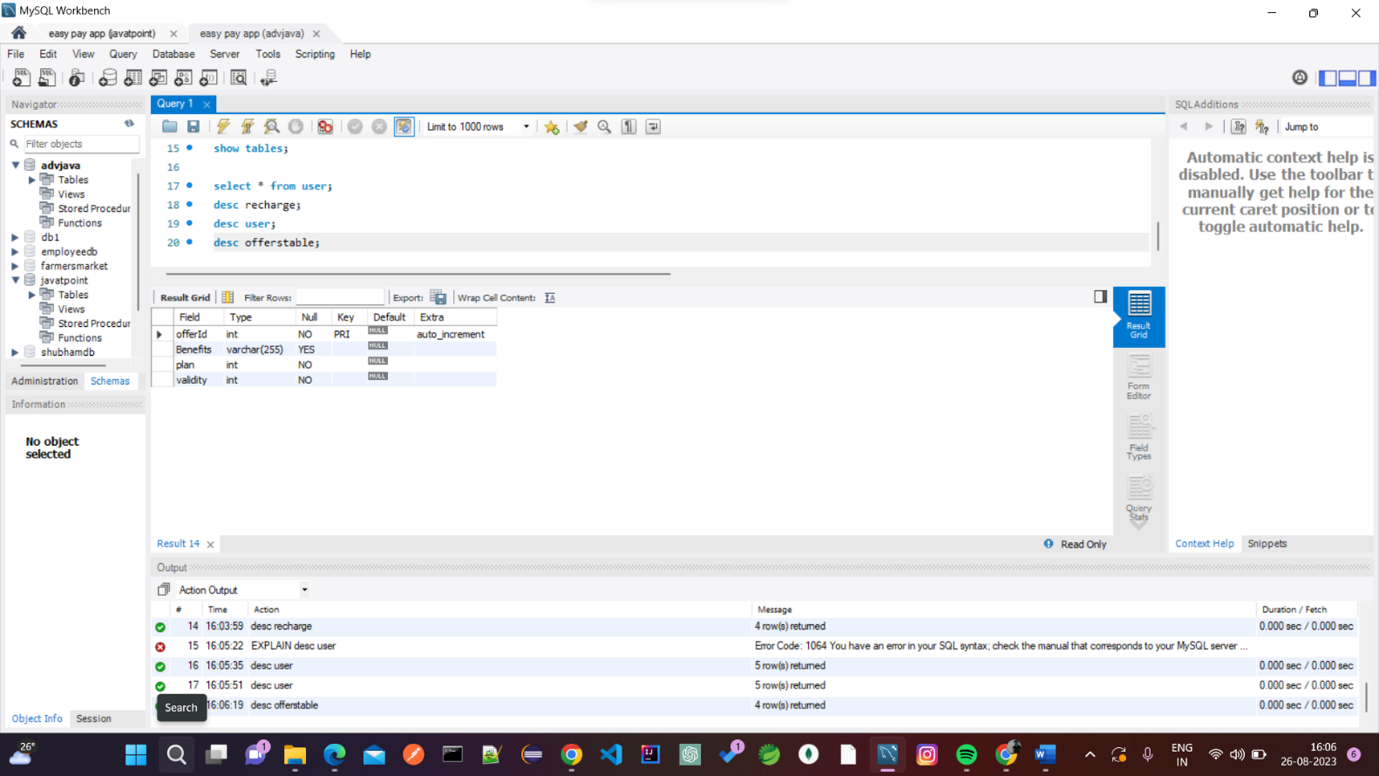

1. Offers Table

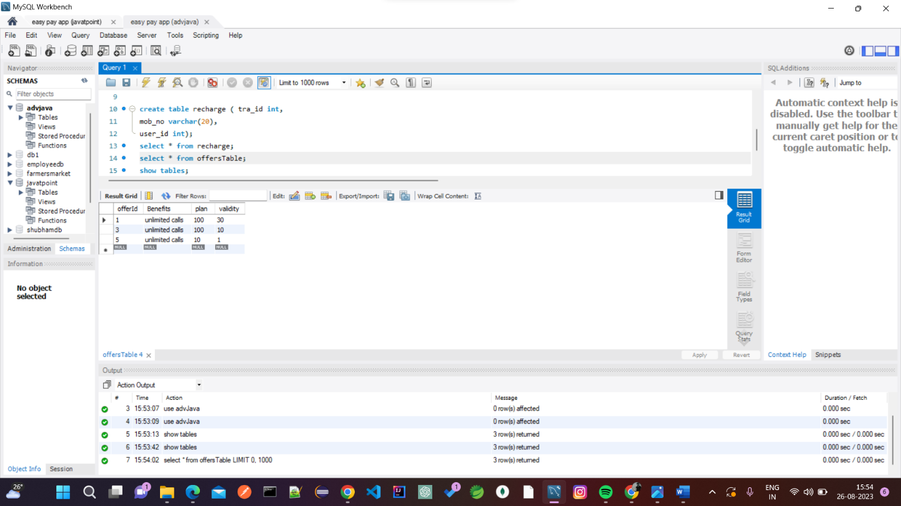

##### USE CASE DIAGRAM

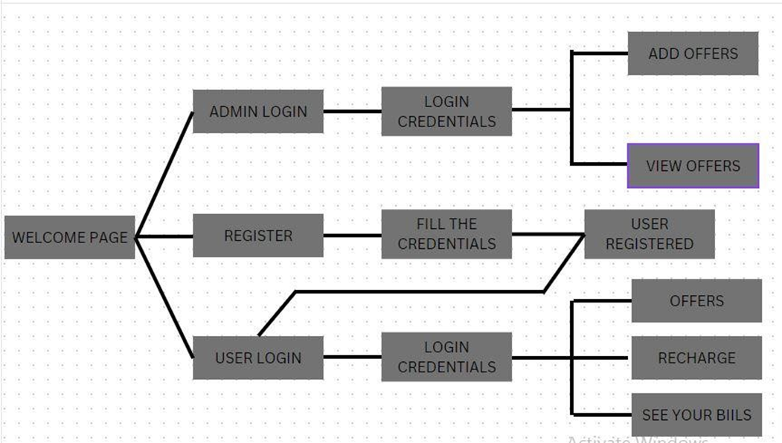

* 1. ACTIVITY DIAGRAM

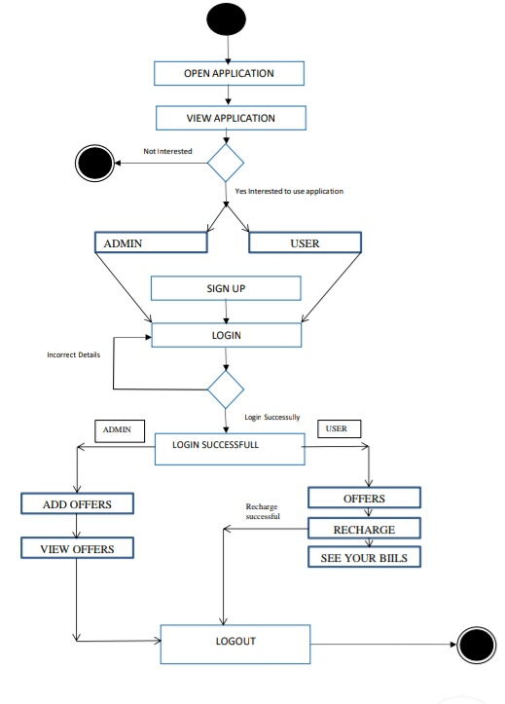

## ROJECT SCREENSHOTS

**WELCOME PAGE:-**

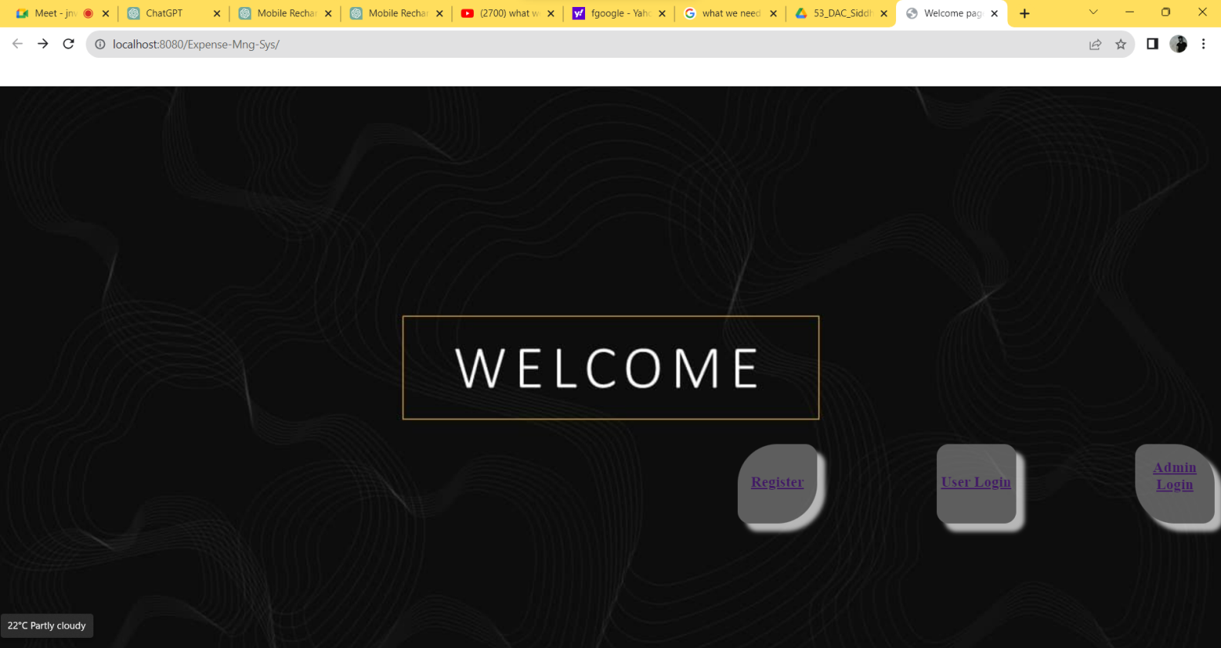

**REGISTER PAGE:-**

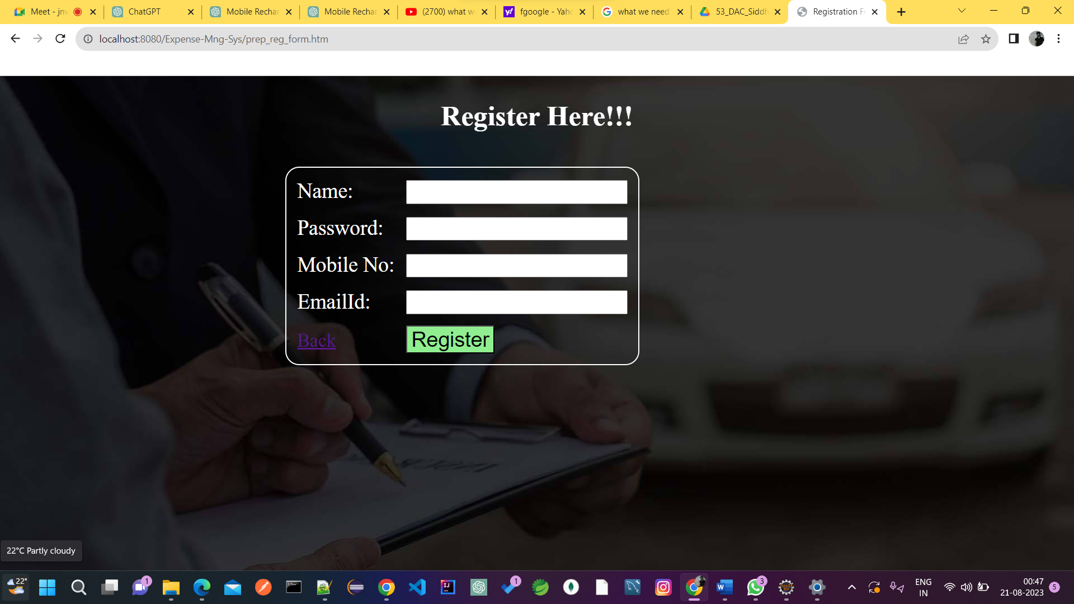

#### USER

**LOGIN PAGE:-**

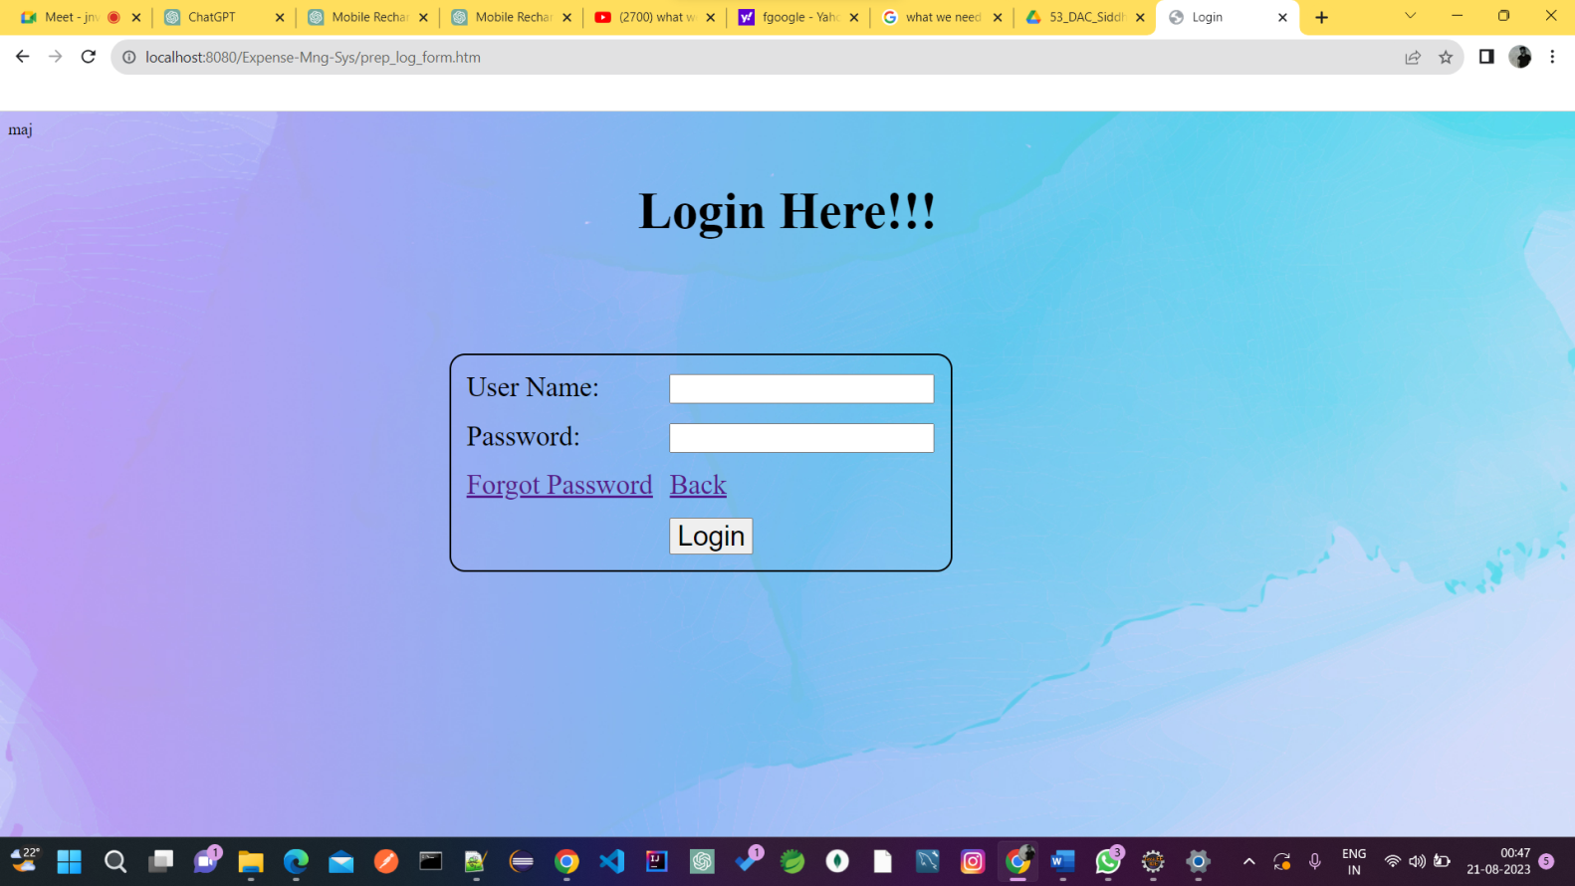

**HOME PAGE FOR USER:-**

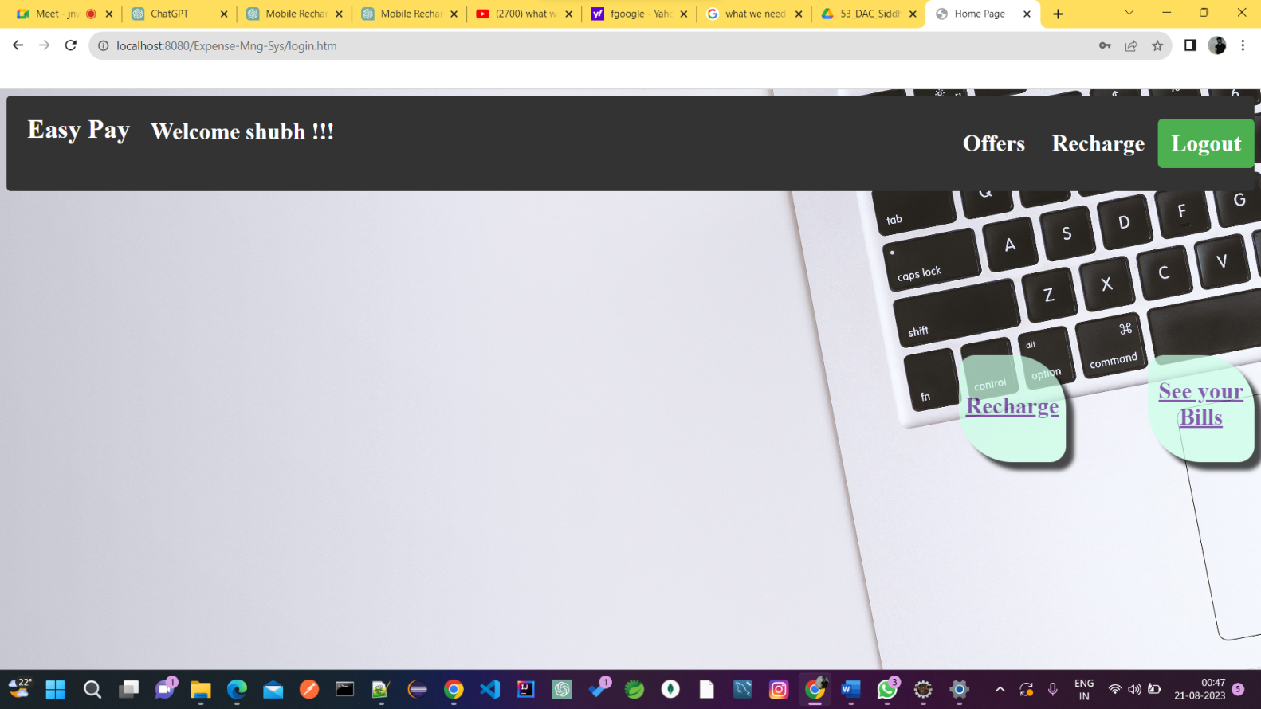

**OFFER LIST FOR USER :-**

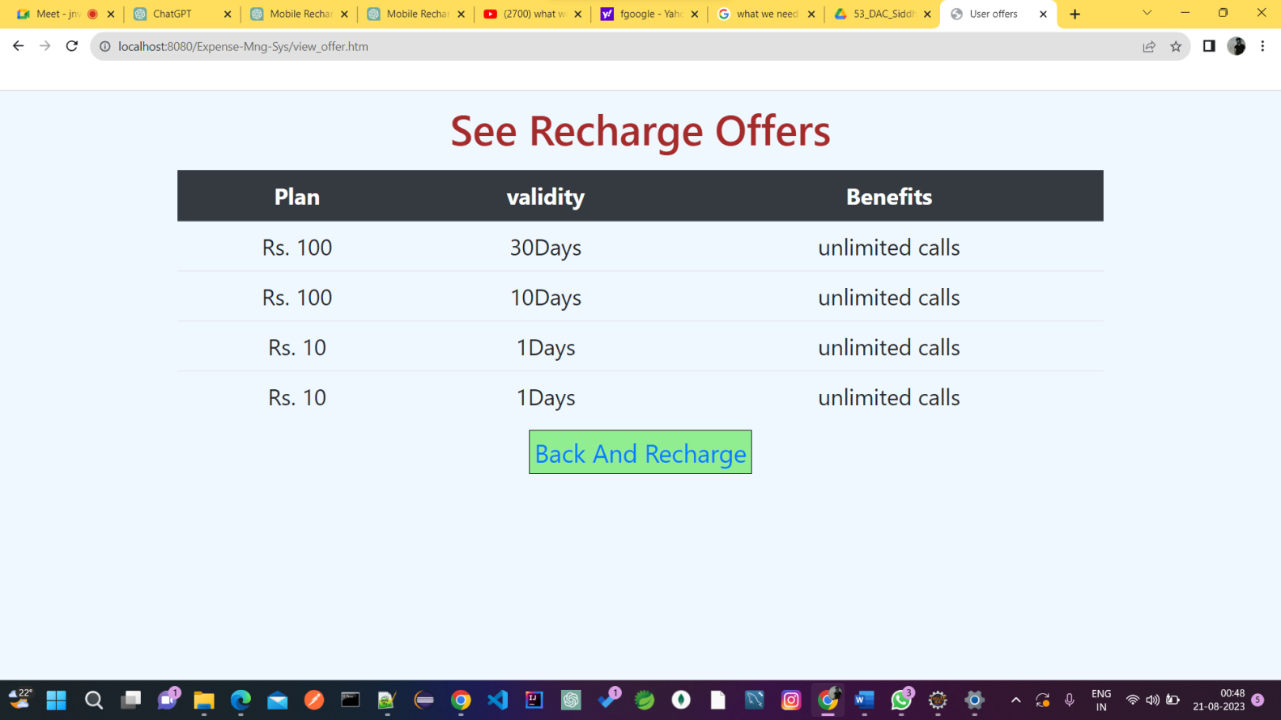

**RECHARGE PAGE :-**

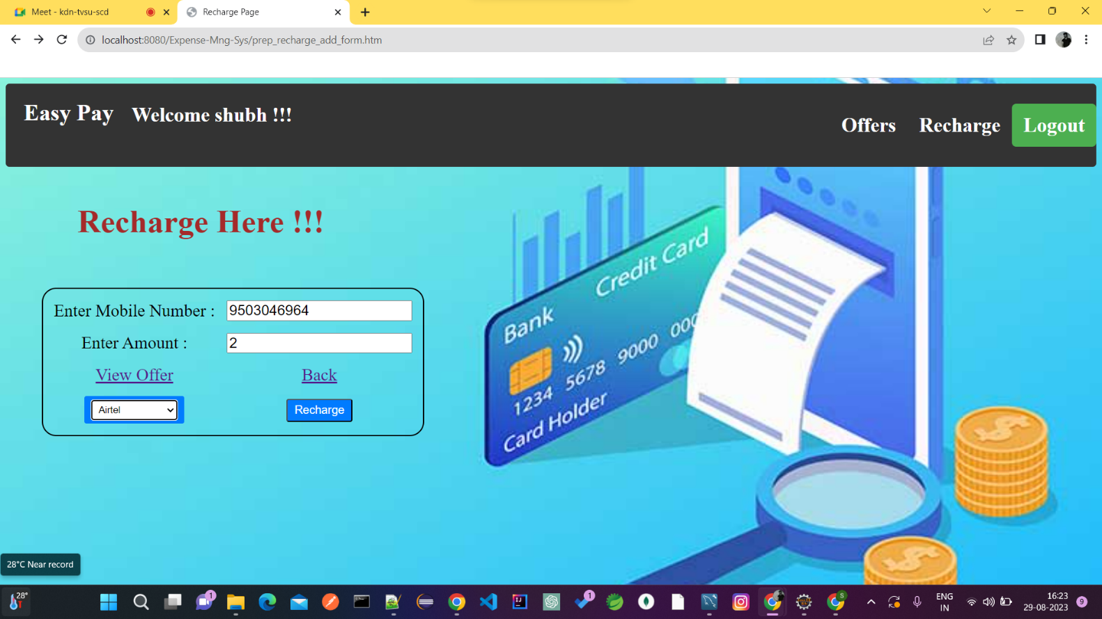

**RECHARGE SUCCESSFUL PAGE :-**

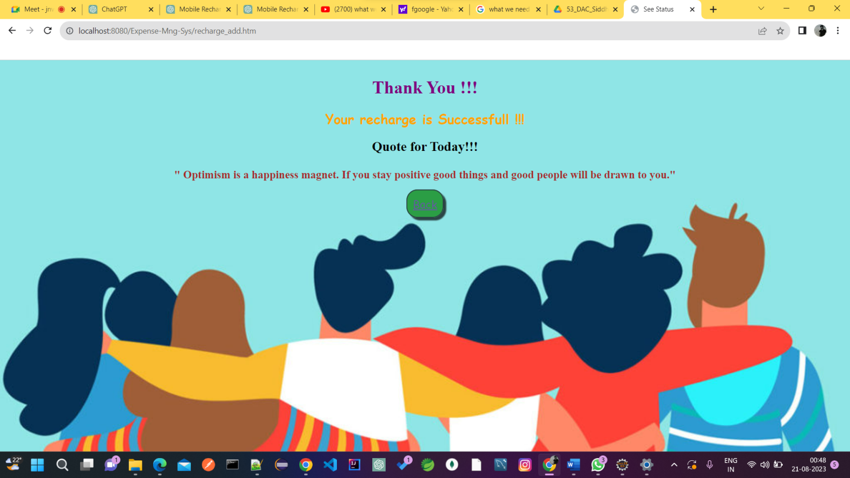

**BILLS PAGE :-**

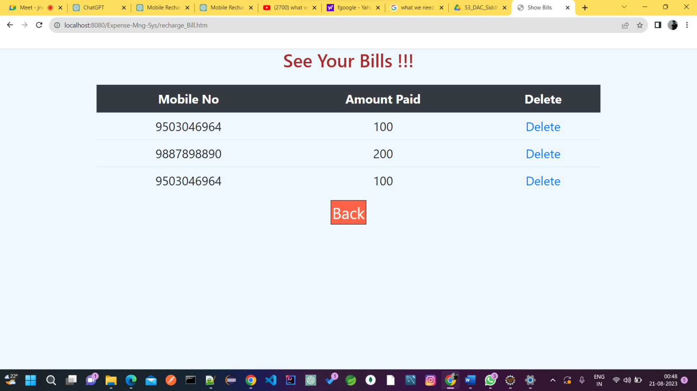

**FORGOT PASSWORD PAGE :-**

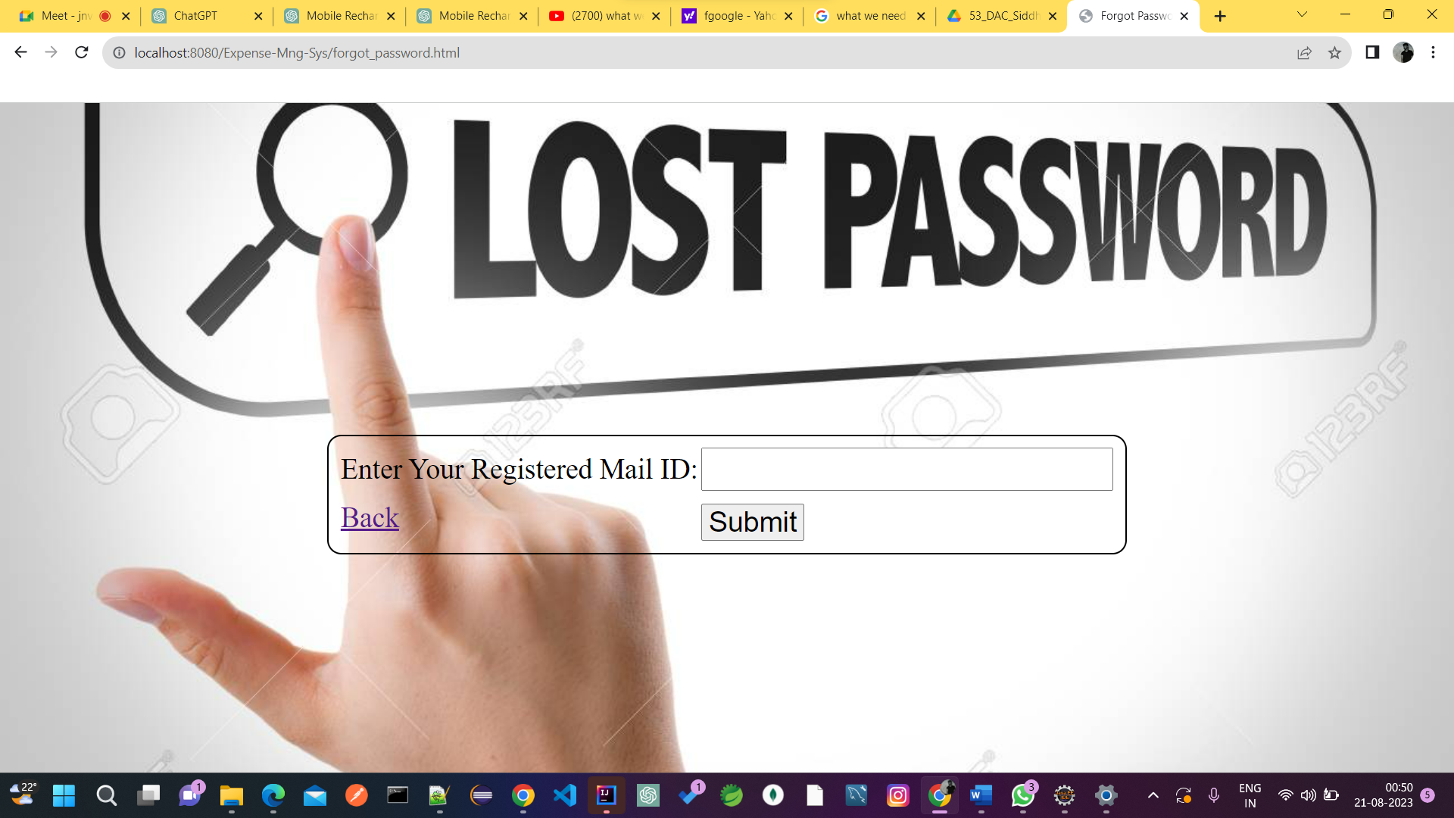

**PAYMENT GATEWAY :-**

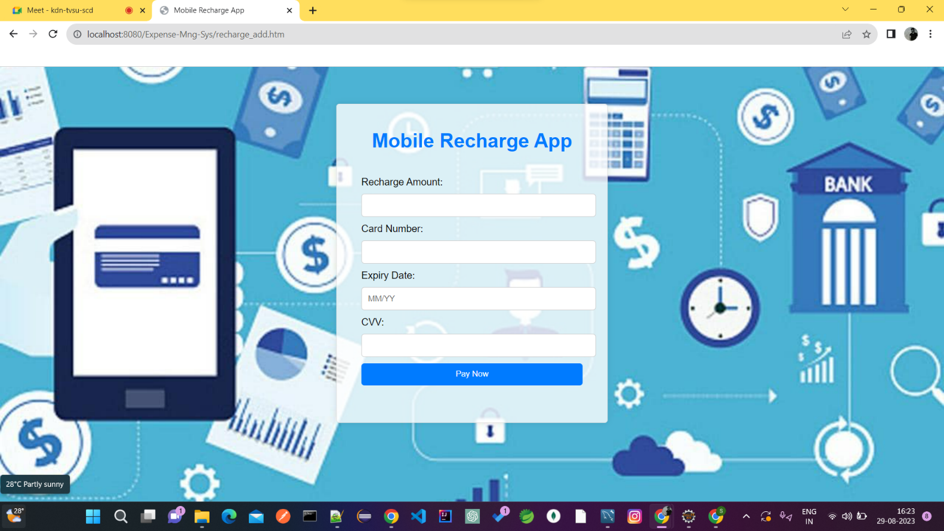

**ADMIN**

**ADMIN LOGIN:-**

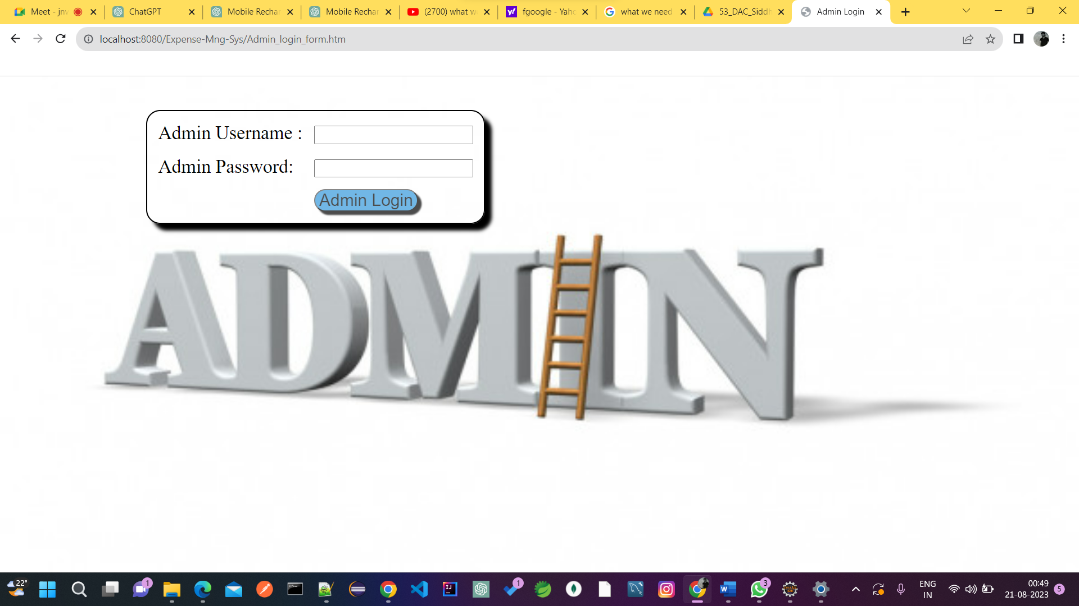

**ADMIN DASHBOARD:-**

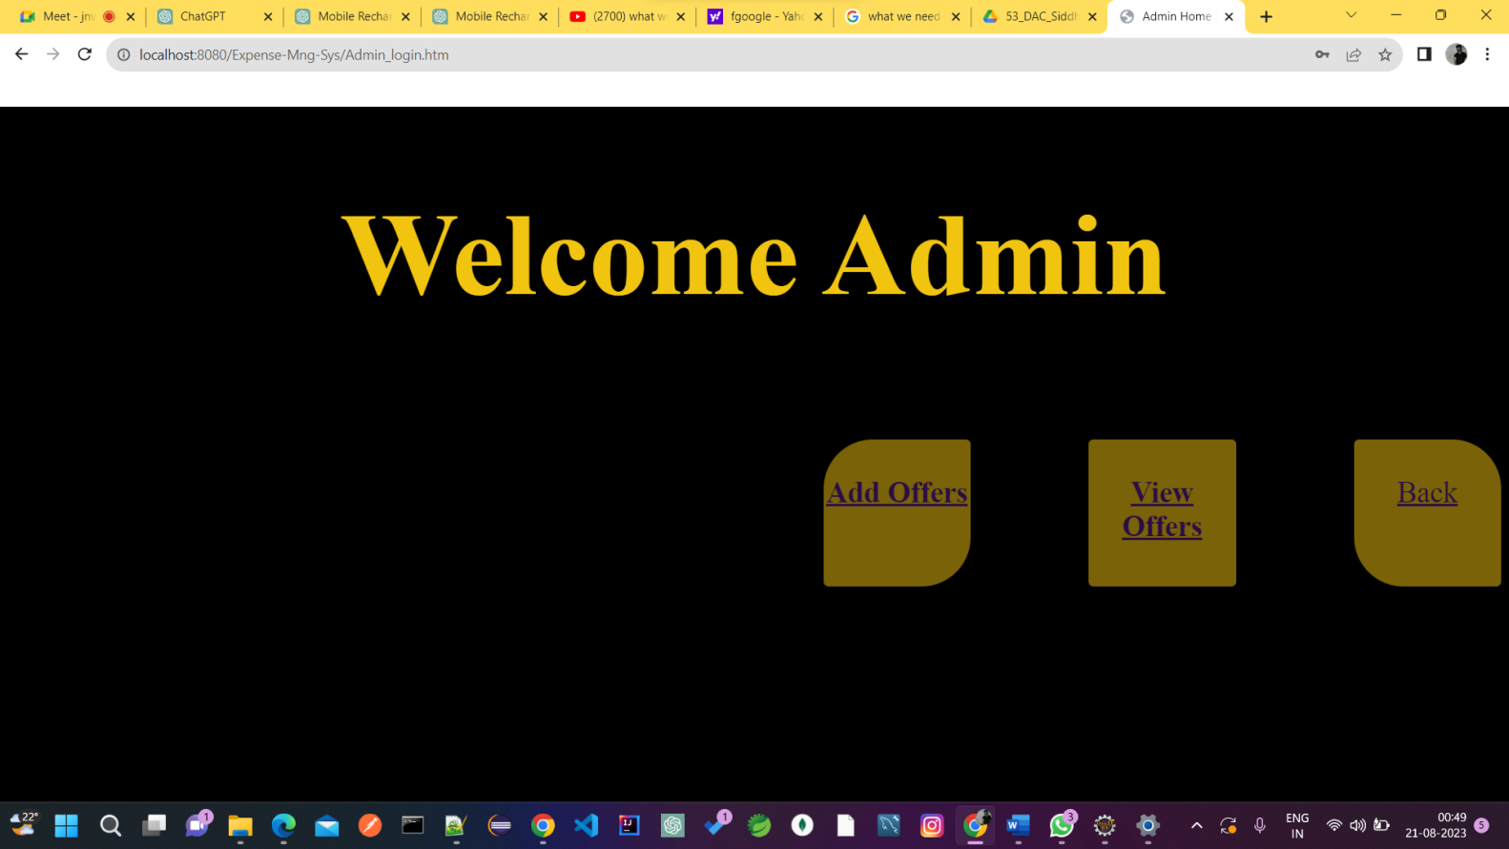

**ADD OFFERS:-**

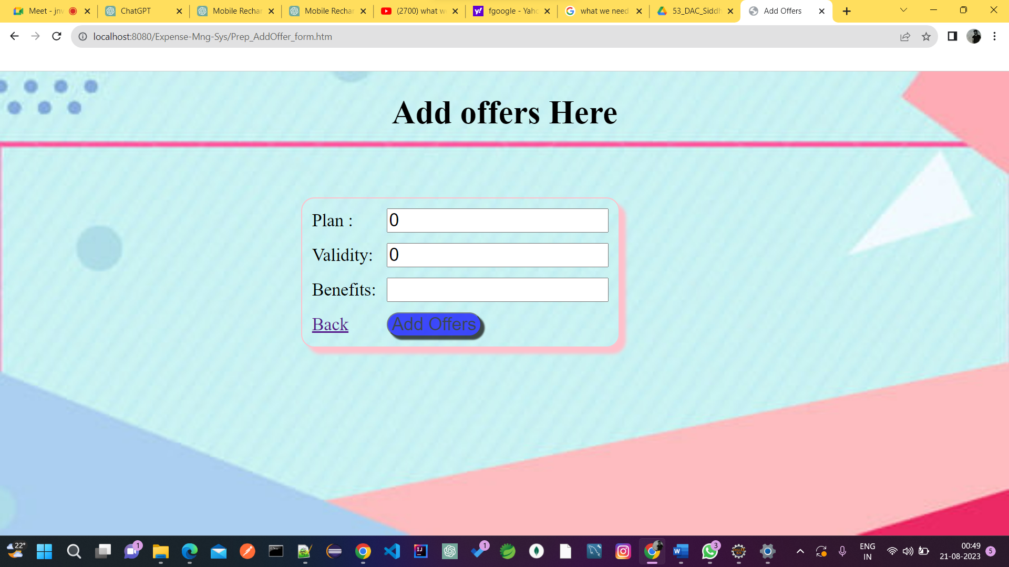

**OFFERS ADDED IN LIST:-**

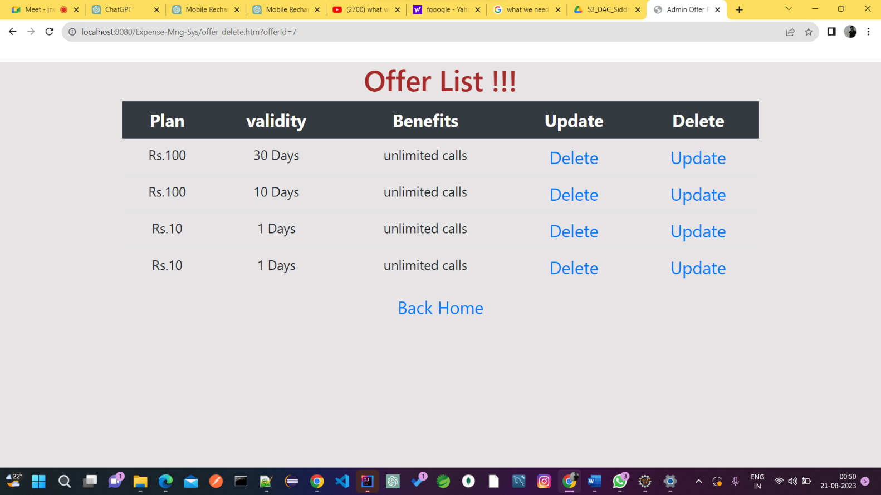

**UPDATE OFFERS :-**

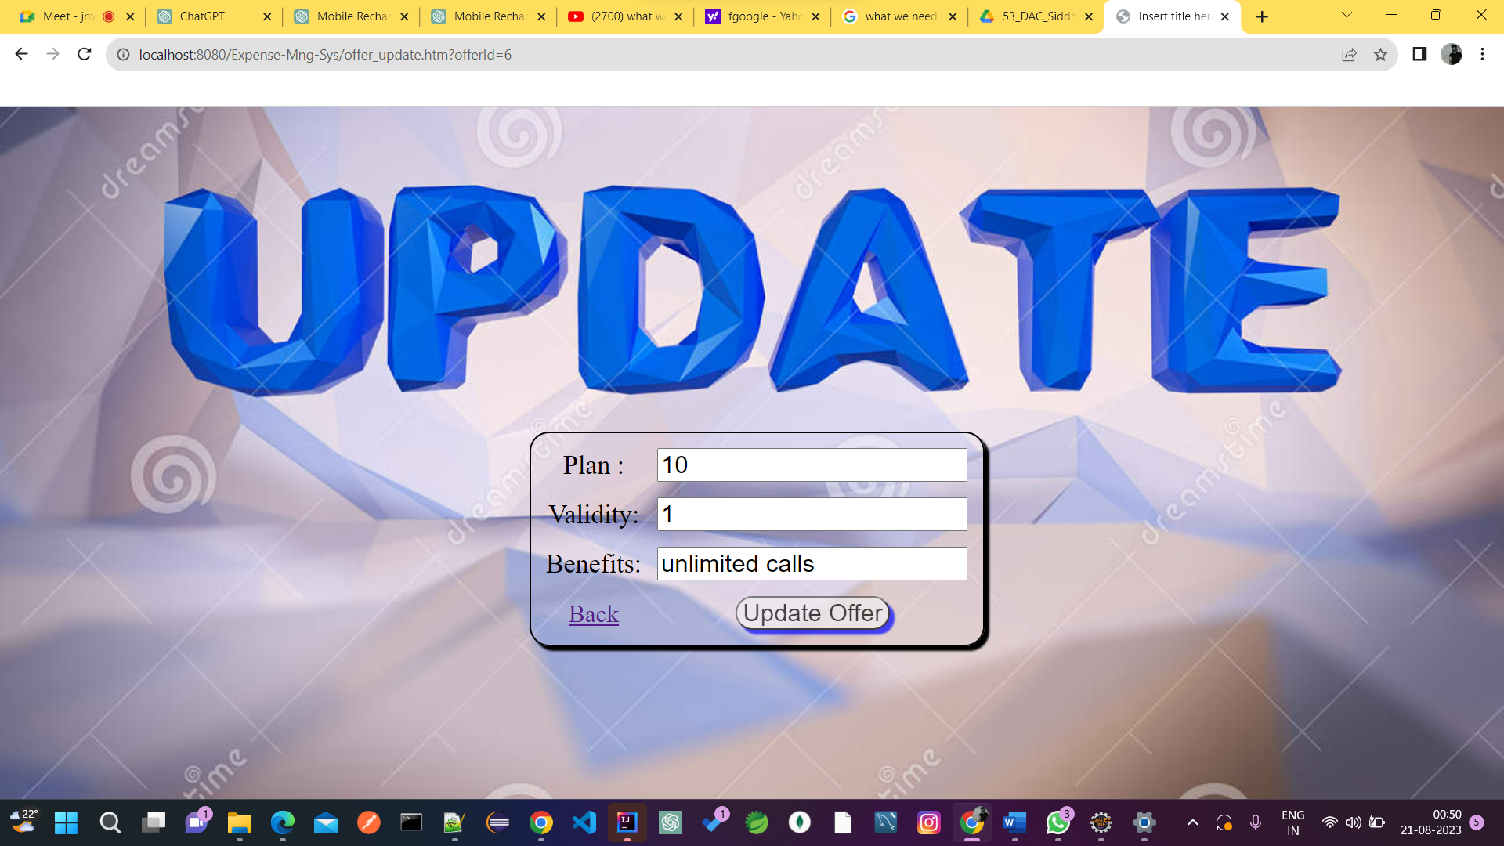

**UPDATE OFFERS LIST:-**

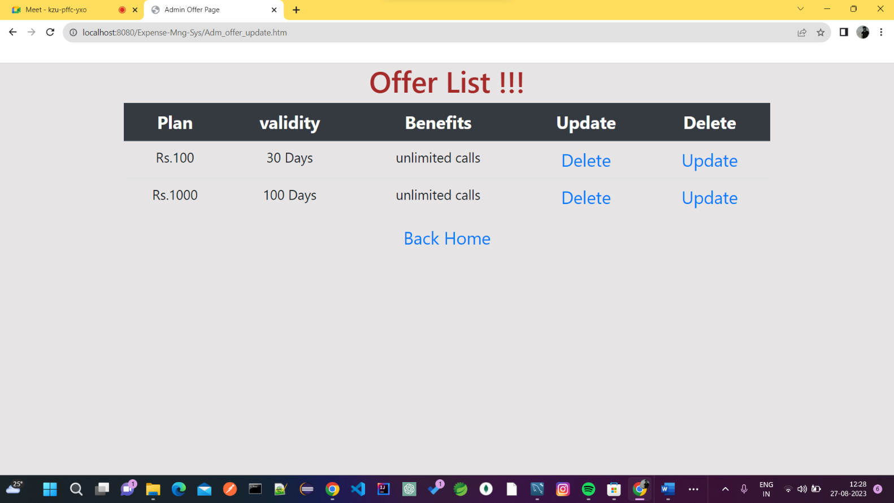

**DELETE OFFERS :-** 

**DELETED OFFERS LIST :-**

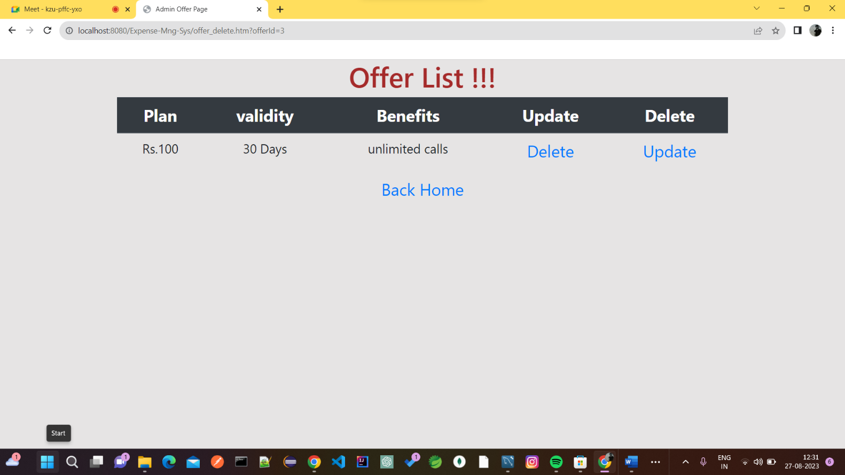

# TESTING

One of the main purposes of testing is to validate and verify that the system works as intended. No program or system design is perfect. However, if we implement the system without proper testing, then it may cause problems and lead to a bad user experience.

Testing and checking outcomes of each test gives us the best chance to detect and

correct errors before the system is implemented in a production environment.

In the course of our project, we made an effort to manually test each component. In

all cases, we obtained the desired results as demonstrated below.

1. USER FEATURES TEST

|  |  |  |  |
| --- | --- | --- | --- |
| # | Description | Outcome | Result |
| 1 | Register customer | New customer details saved in thedatabase. | Passed |
| 2 | Login as customer | Fetched authenticated user details saved in  database. | Passed |
| 3 | Offers Table | Fetched list of all offers from the database. | Passed |
| 4 | Recharge | User will enter the details for recharge and it will be stored in the databse | Passed |
| 5 | See Your Bills | Fetched list of all the previous recharges made by users from database | Passed |
| 6 | Logout | The session was cleared. | Passed |

1. ADMIN FEATURES TEST

|  |  |  |  |
| --- | --- | --- | --- |
| # | Description | Outcome | Result |
| 1. | Sign in as Admin | Fetched authenticated admins details | Passed |
| 2. | Add New Offer | The Admin will add offers. And it will saved to the database. | Passed |
| 3. | Update Offer | Admin can update the existing offers which will be saved in the database. | Passed |
| 4. | Delete Offer | Admin can delet the irrelevant offers which will also be deleted from the database. | Passed |
| 5. | View Offer | The offer list fetched from the database and admin can see the list of offers | Passed |
| 6. | Logout | The session was cleared. | Passed |

# CONCLUSION

In conclusion, the mobile recharge app project has achieved its goal of providing users with a user-friendly and secure platform for managing their mobile recharges. The app's intuitive interface and robust security measures ensure a seamless and safe transaction experience. By offering customizable plans, transaction history tracking, and notifications, the app goes beyond basic recharges. Despite challenges, the project successfully leveraged technology to simplify digital transactions and contribute to the ongoing digital economy trend. The collaborative efforts of the development team and the adoption of modern tools have culminated in a practical and efficient solution that meets user needs and expectations.

.

## FUTURE SCOPE

Using whatever we have learnt over the duration of this course, we tried to make our project as user-friendly and gave it as many features as possible in the limited time allotted for the project work. That said, there are certainly more features that can be added to our application. Some of those are mentioned below:

* The most recharged plan can be highlighted as users favorites.
* Rating chart for Users will be provided to get feedbacks.
* Discounts Vouchers can be given on a per-user basis depending on the users purchase history.
* Users can upvote/downvote/report feedbacks.
* In case the user forgets the password, a ‘reset password’ functionality can be added which will be done by with the help of email.
* Alert’s / pop up’s will be added for successful validation.
* CAPTCHA can be added to login page.

## REFERENCES

**Following is the list of websites we referred during the course of our project:**

* https://getbootstrap.com/docs/5.1/getting-started/introduction/
* https://[www.baeldung.com/](http://www.baeldung.com/)
* https://[www.w3schools.com/](http://www.w3schools.com/)
* https://docs.spring.io/spring- data/jpa/docs/current/reference/html/#reference
* <https://javaee.github.io/javaee-spec/javadocs/>
* https://javadoc.io/doc/org.springframework.data/spring-data- jpa/latest/index.html

THANK YOU !!